Group project Research (Week 2)

Task- Research and design characters which will elicit laughter

Theme 1-

more realistic in design perhaps (darker colors clashing against the brighter, warm colors of the environment). Example include typical army men as the default enemy, zombies as the slower but more defensive, and rabid/demonic dogs as the smaller and faster but weaker enemies, etc. Whilst by itself would not evoke laughter, it would come from the satirical nature of the game. Laughter cause by sheer novelty of fighting off these enemies with the random weapons (Fighting of demons with a banana, a tennis racket and some beer coasters).

Probably not the best way to approach as the design itself doesn’t fit the criteria given and is subject to the player understanding the irony behind it. However, it does possibly keep in tone with the initial game idea. Maybe used in the title screen to subvert expectations on the games approach to its design. (player expecting a gritty, if generic, First Person Shooter)

Theme 2-

Enemy design is cartoony, fits more in theme with the weaponry theme. Significant oddities with facial structure (lazy, wide eyes, huge slanted nose, different sizes for the same part) and body shape (ranging from incredibly lanky to short and stacked). Probably more humanoid designs for each of the enemy types but easily distinguishable. Evokes laughter and possibly slight confusion from the bizarre character design. Enemies would also have a strange assortment of weapons, similar if not the same as the player character. The design should still be semi grounded, as too much surrealism won’t evoke the emotion that we are going for and would leave the player too confused (would also ruin player immersion).

The most optimal route of approaching the task. Fits the games theme well, allows for a lot more variety in approaches to enemy variation. Additionally, it is Simpler and less time consuming as well in terms of designing and giving life via basic animation frames.

Theme 3-

Enemy design is just objects found in an everyday bar. ‘What would a drunk person consider an enemy/obstacle). Examples such as; out of place tables/chairs, dry ice smoke from a dancefloor, other drunks. More like hallucinations of the drunk person (example; the smoke becomes like a solid wall, inanimate objects are moving on their own accord). Evokes laughter as it a weirder take on enemy designs in a FPS, as oppose to the other two themes.

Again, another novelty approach to the task, whilst it might not be best in terms of enemy design, it can be used for designing collectibles. Keeping the game design closer to reality so it doesn’t lose it completely trying to appeal to the players sense of humor via randomness and slight incoherence.

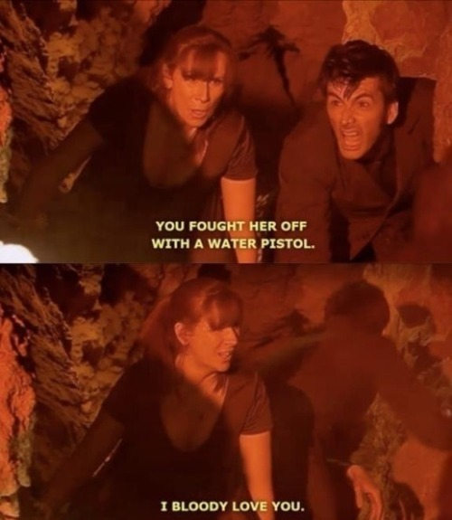Image Reference/basic Mood Board- Theme 1

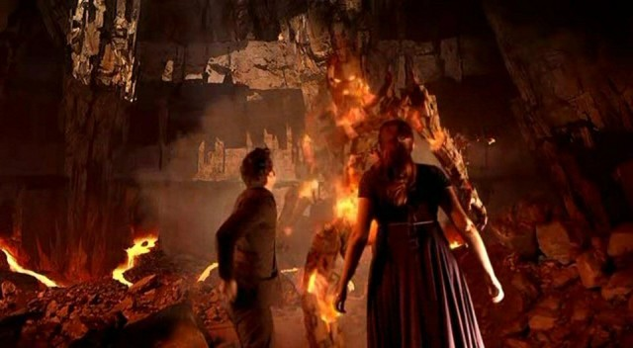

Idea was partially inspired by the likes of Doctor Who (Season 4 Episode 2)

Additionally, enemy design from the game that we are parodying in terms of gameplay and design, Doom

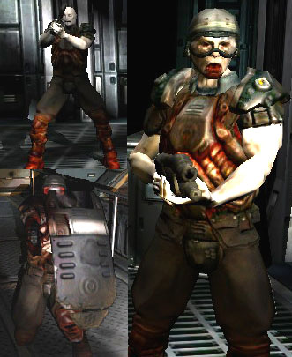

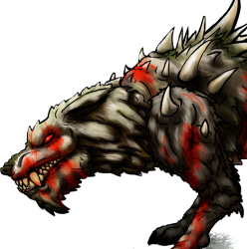

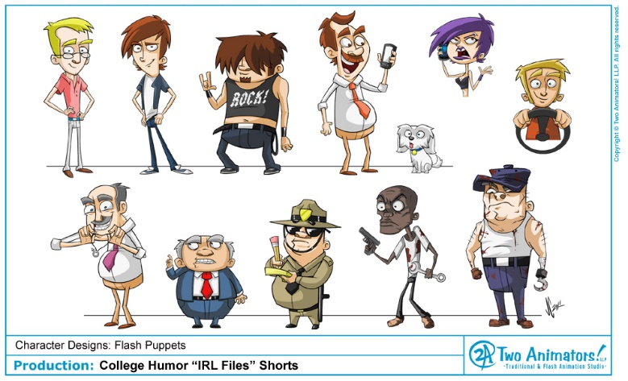Image Reference/basic Mood Board- Theme 2

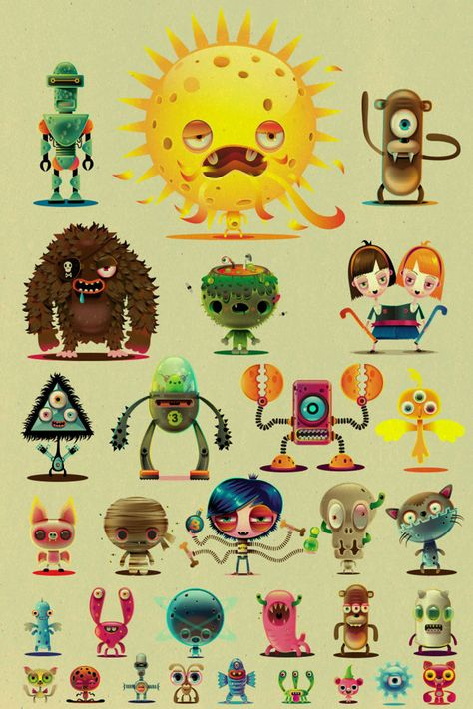

Multiple styles can be applied to this type of design, provided it can still be followed without to be explained

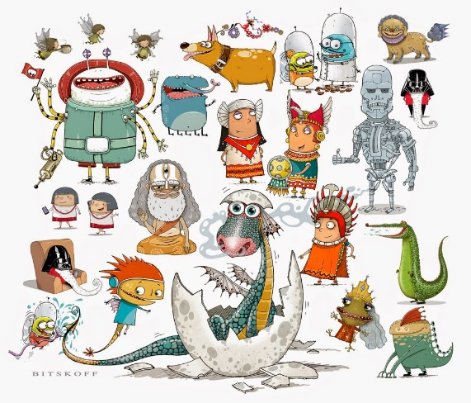

Image Reference List

‘water pistol’: <https://www.tumblr.com/tagged/water-pistol> (Last accessed 10/02/2019)

Bloodied Wolf: <https://opengameart.org/content/fenrir-wolf-sprite-injuries> (Last accessed 10/02/2019)

Cartoon Dragon: <http://bitskoff.blogspot.com/2014/08/character-design-cute-and-simple.html> (Last accessed 10/02/2019)

Character Designs (Flash Project): <http://twoanimators.blogspot.com/2011/02/character-designs-irl-files.html> (Last accessed 10/02/2019)

Doctor Who enemy ‘Pryovile’: <https://www.themarysue.com/doctor-who-cuusoo/> (Last accessed 10/02/2019)

Enemy Soldier (Doom): <http://daicarius.blogspot.com/p/doom-3.html> (Last accessed 10/02/2019)

Fightmymonster: <https://www.pinterest.co.uk/pin/443252788299343021> (Last accessed 10/02/2019)